1. Basic tutorial of w3school(I use this website for learning SQL first time): <http://www.w3school.com.cn/sql/index.asp>
2. This is different join(left, right…) picture(I think this is really great):

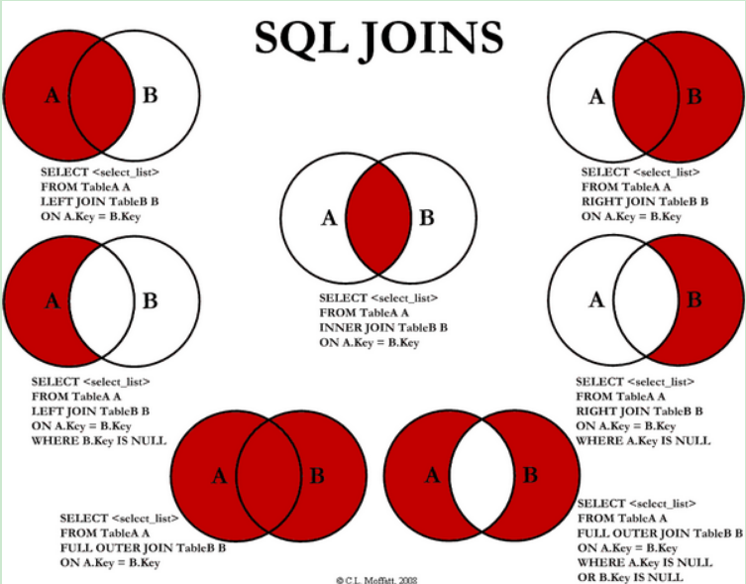

1. Really Great article for Hive function(I will search some functions during work): <https://www.cnblogs.com/MOBIN/p/5618747.html>